**TASK#01**

Take two inputs and subtract.

**Solution**

//IN

//STO 97

//IN

//STO 98

//LDA 97

//SUB 98

//OUT

//HLT Halt

//*98

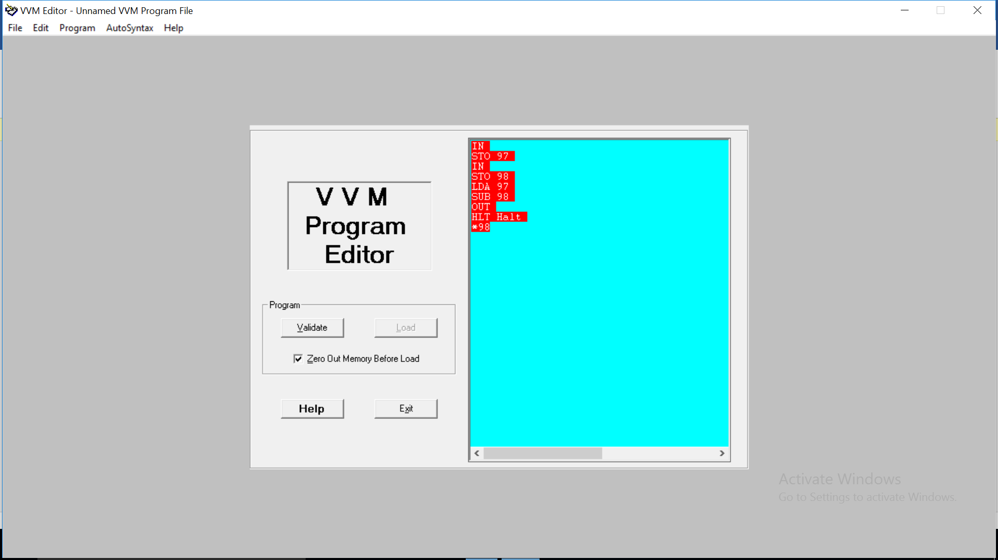 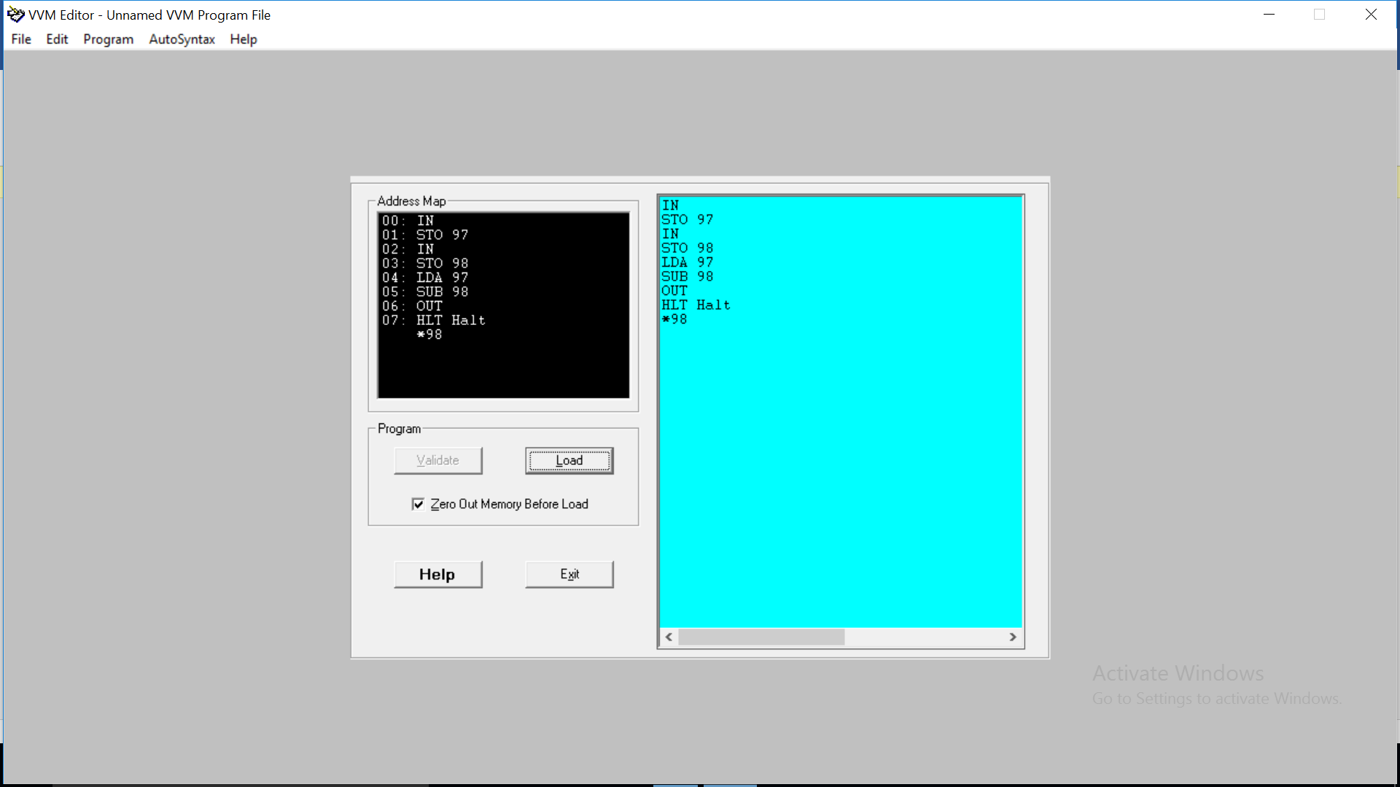

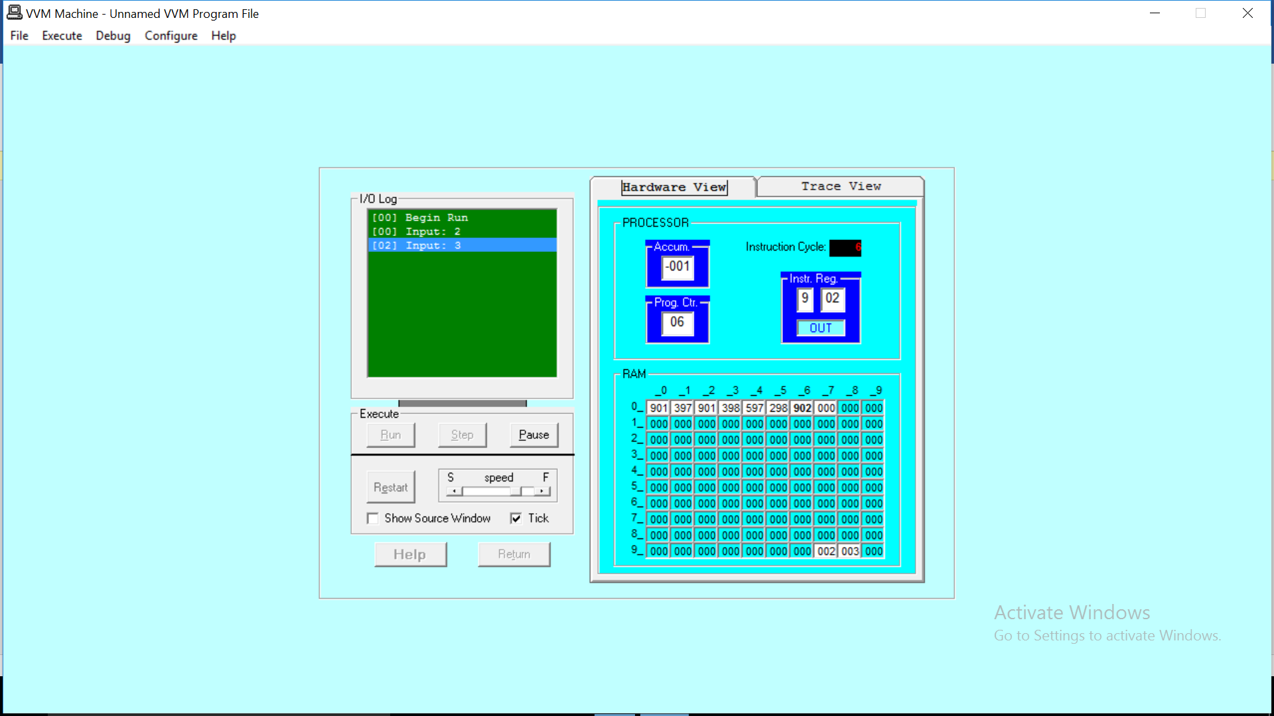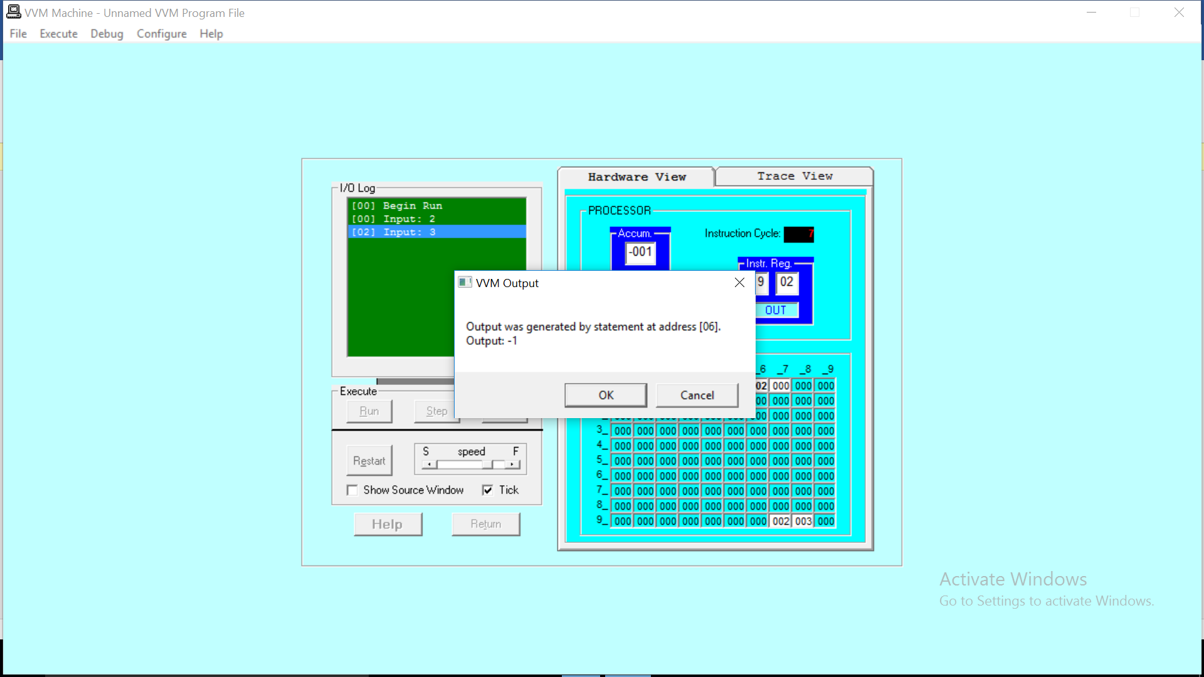

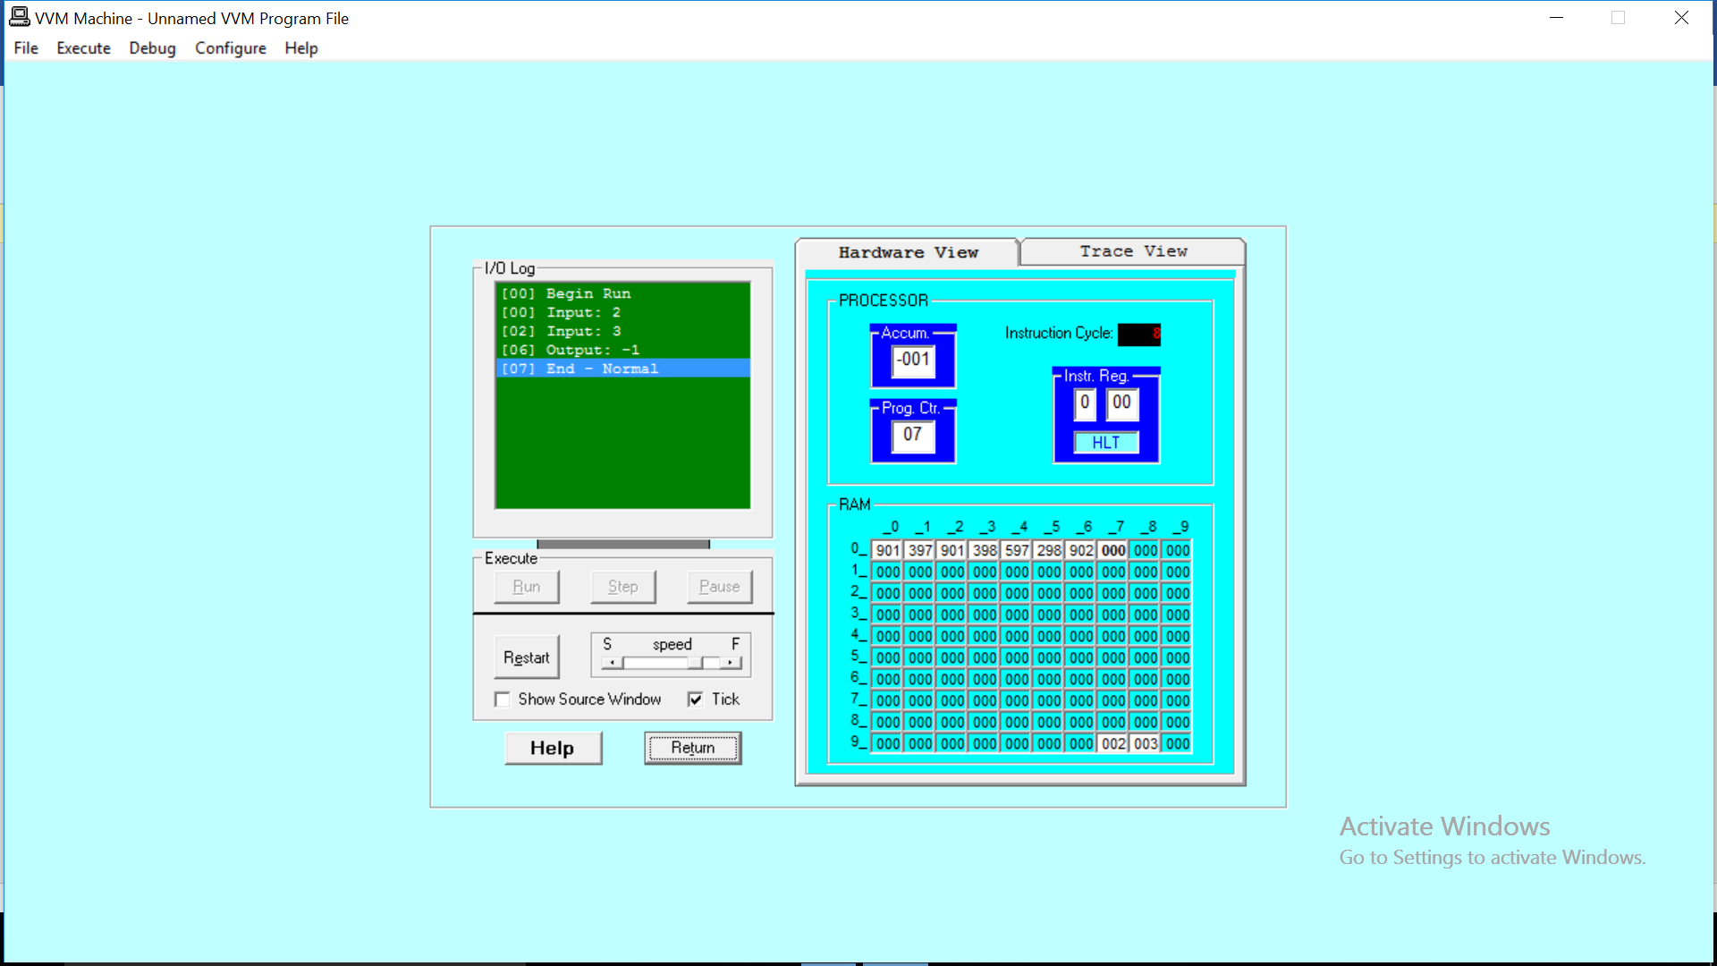

**Output:**

**Hardware view:**

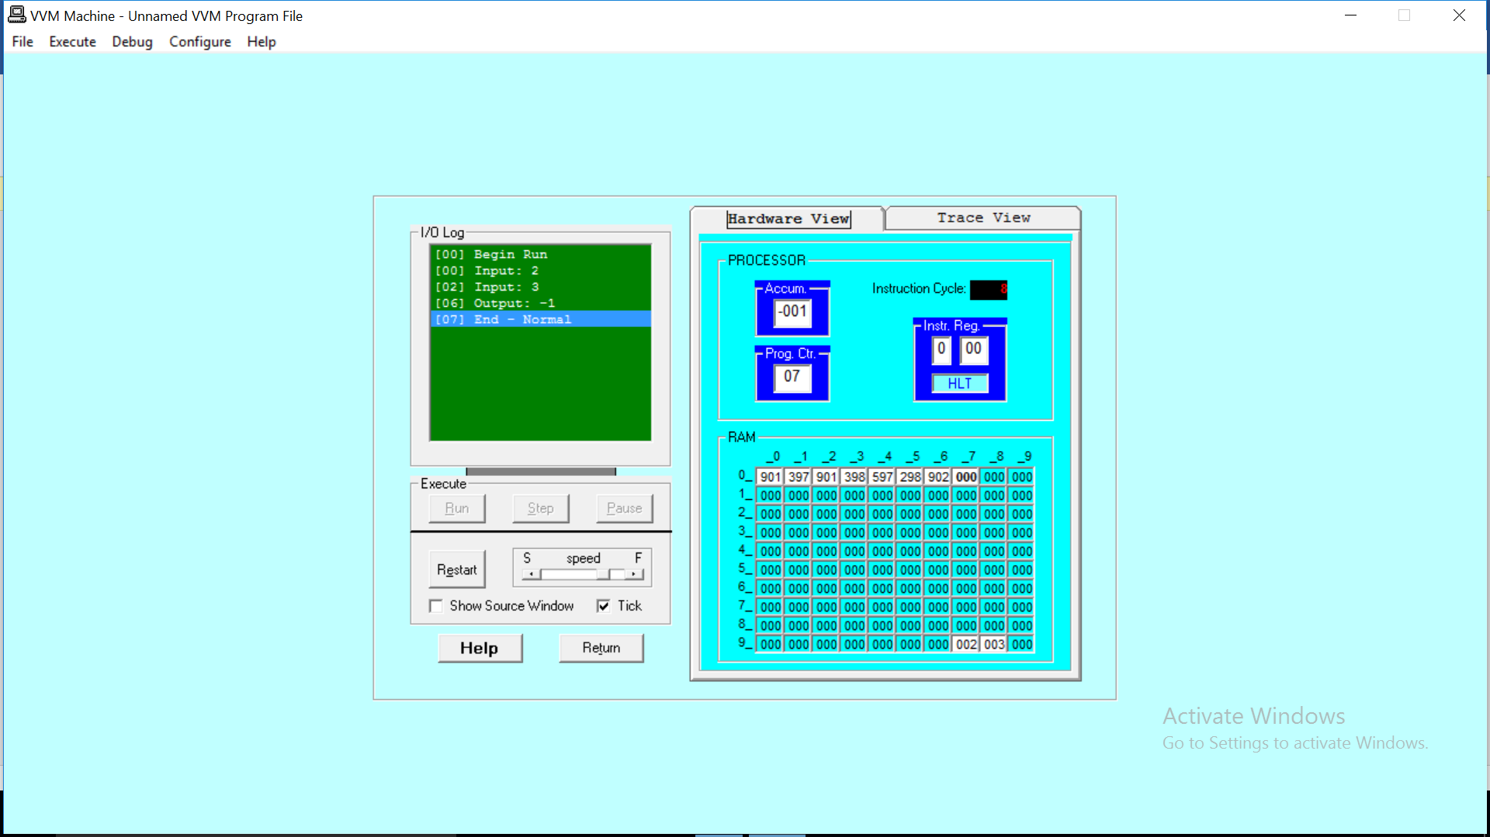

**Trace view:**

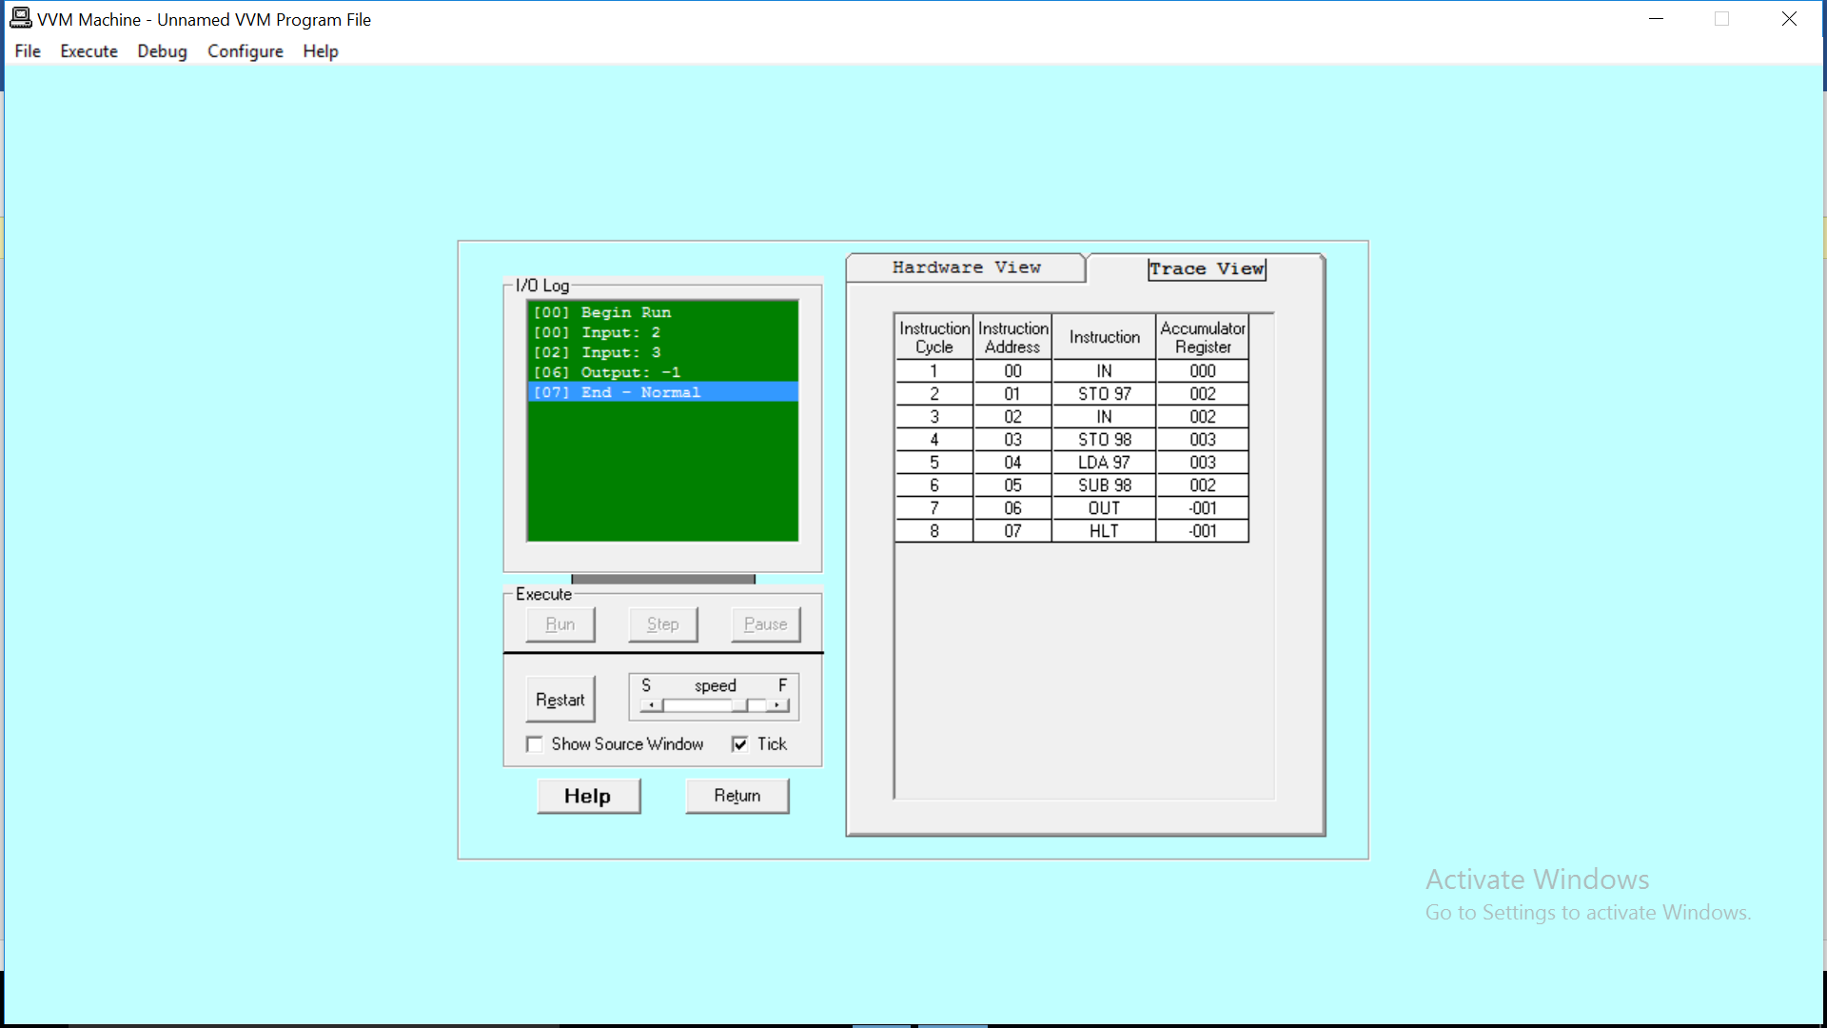

**TASK#02**

To take 2 hardcoded input and ADD them.

//LDA 35

//ADD 36

//OUT

//HLT

//*35

//DAT 99

//*36

//DAT 36

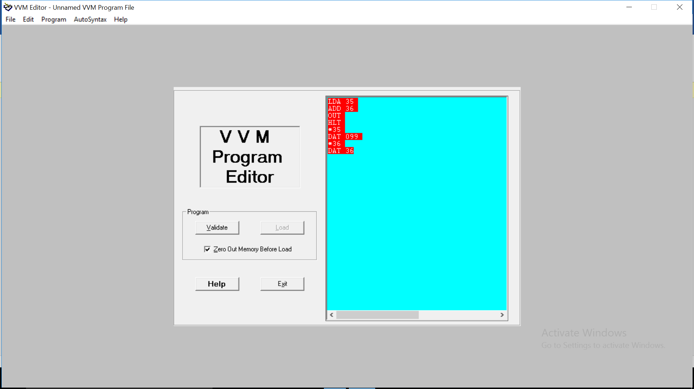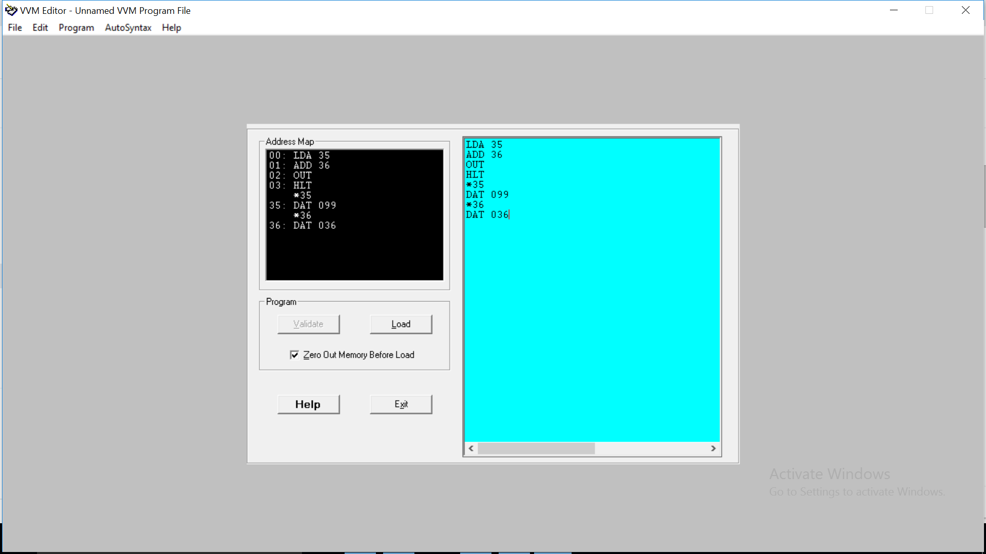

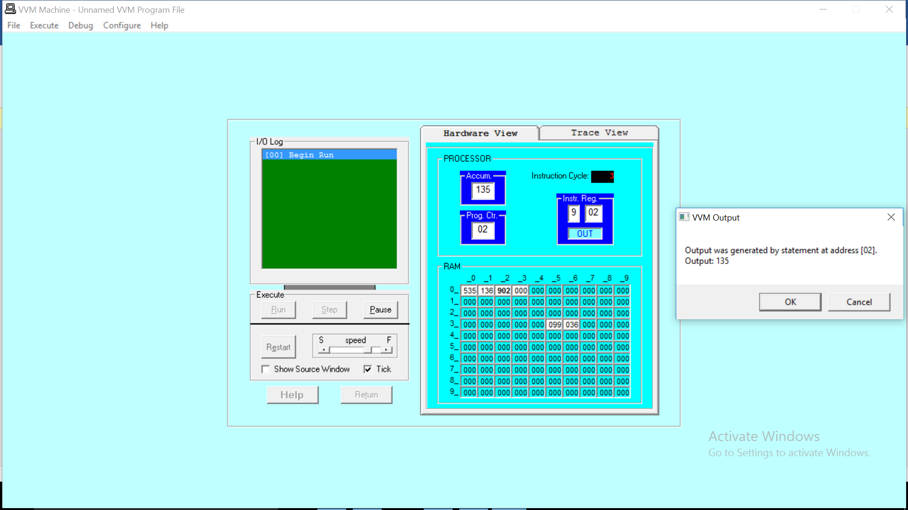

**OUTPUT: Hardware view & Trace view**

